Google Classroom step-by-step instructions
Below are step-by-step instructions on how to log into Google classroom and access your class. The recommended web browser to use is Google Chrome. If you are using an Apple device the recommended web browser is Safari.

- Open Google Chrome web browser
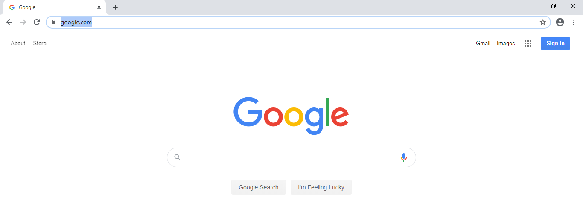
- Type classroom.google.com in the web browser like below and press enter.

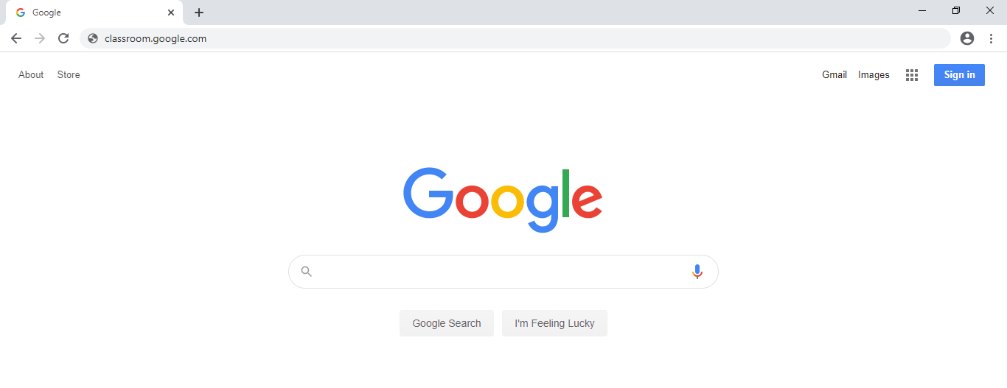
- Then you will see the login screen where you will need to enter the username given to you from the school.
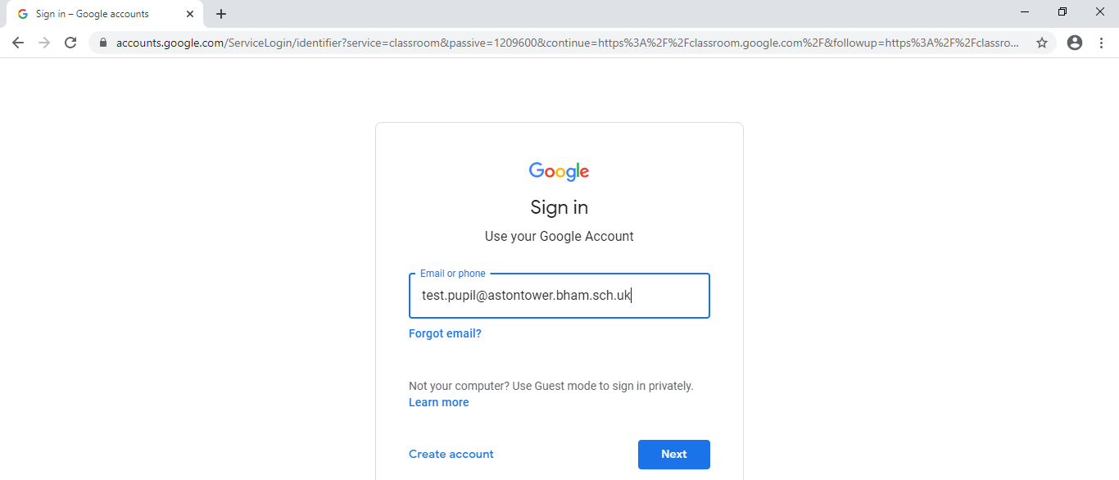

- Once you have typed in your username you will have to click on Next. That will take you to the password screen like below.
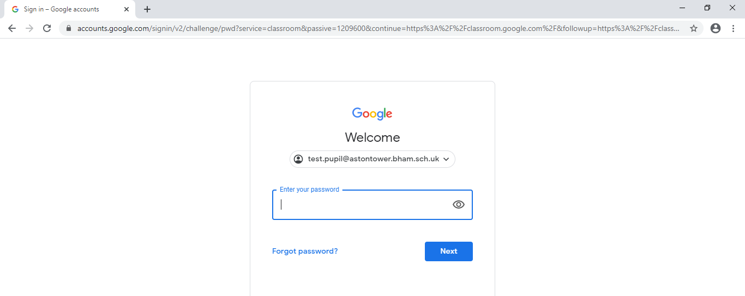

- You will have to enter the password given to you from the school and click on Next.
- Once you enter your password and click Next, you will be taken to the following scree:
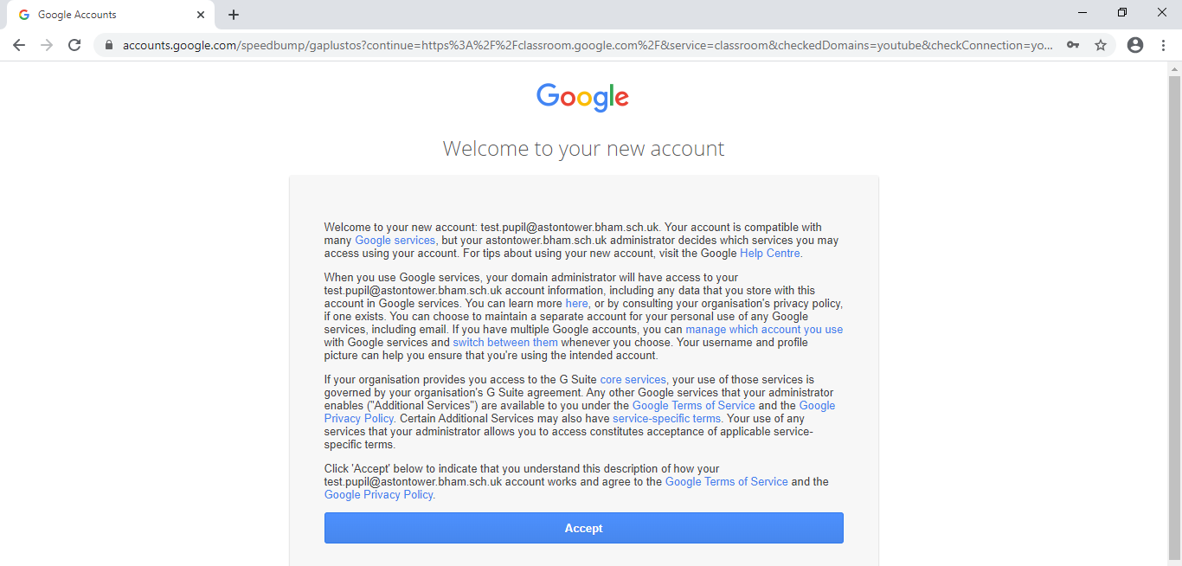
- At the above screen you will have to click on Accept.
- Once you have accepted the term and conditions, it will take you to the screen below:
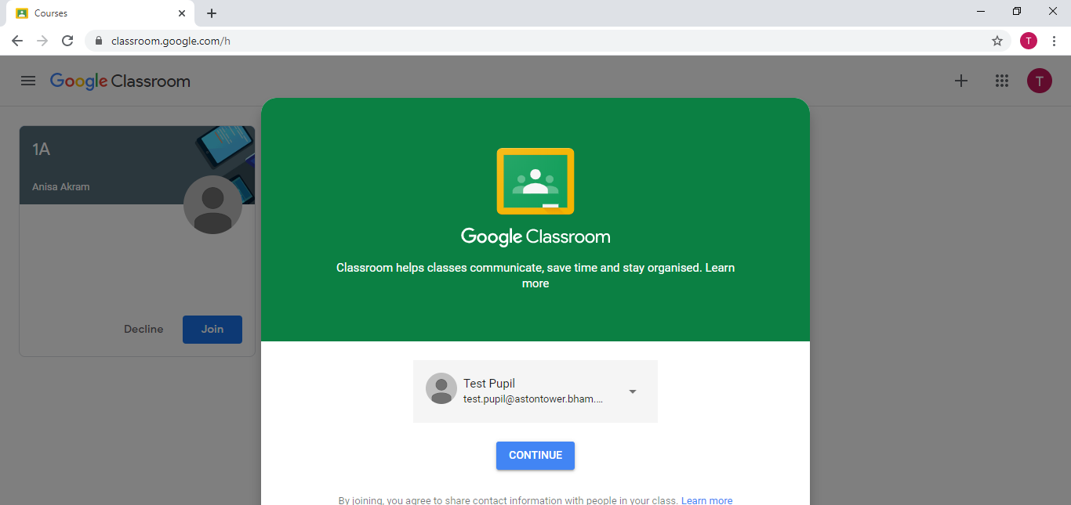

- At the above screen you will need to click on Continue.
- After clicking on Continue, it will take you to the screen below:
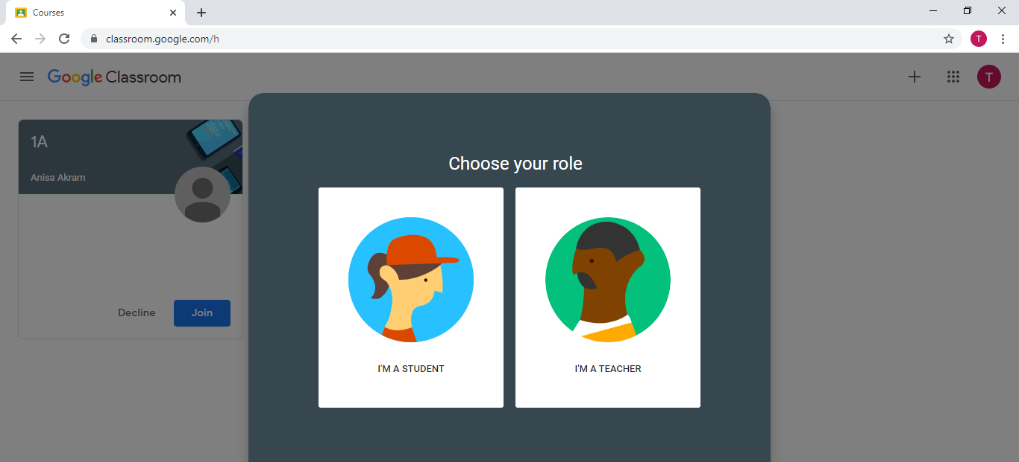

- It is very IMPORTANT that you click on I’M A STUDENT here.
- After clicking on the Icon I’M A STUDENT it will take you to the screen below:
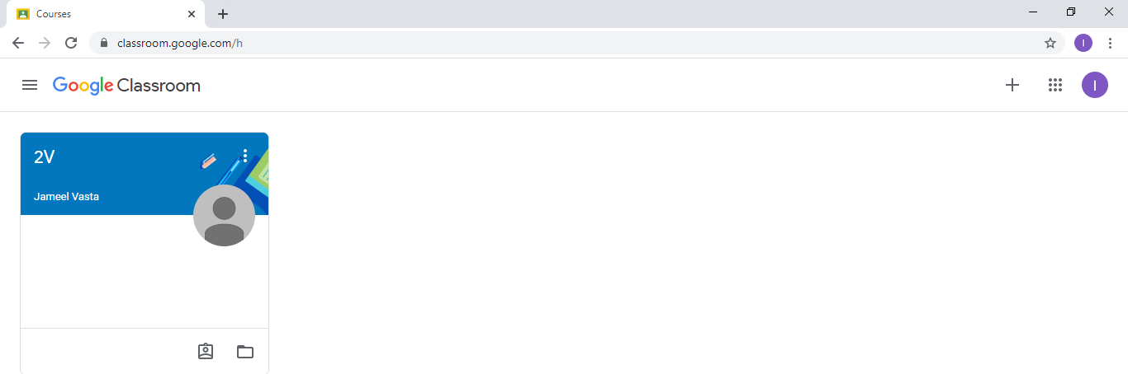

- The above screen show that you are a member of 2V class and has the teachers name.
- You might get the screen below where you have been invited to join a class. It is IMPORTANT here that you click on Join to join your class. This will have the Class name and the Teachers name. If you don’t have the option to join, that means you are already a member of the class.

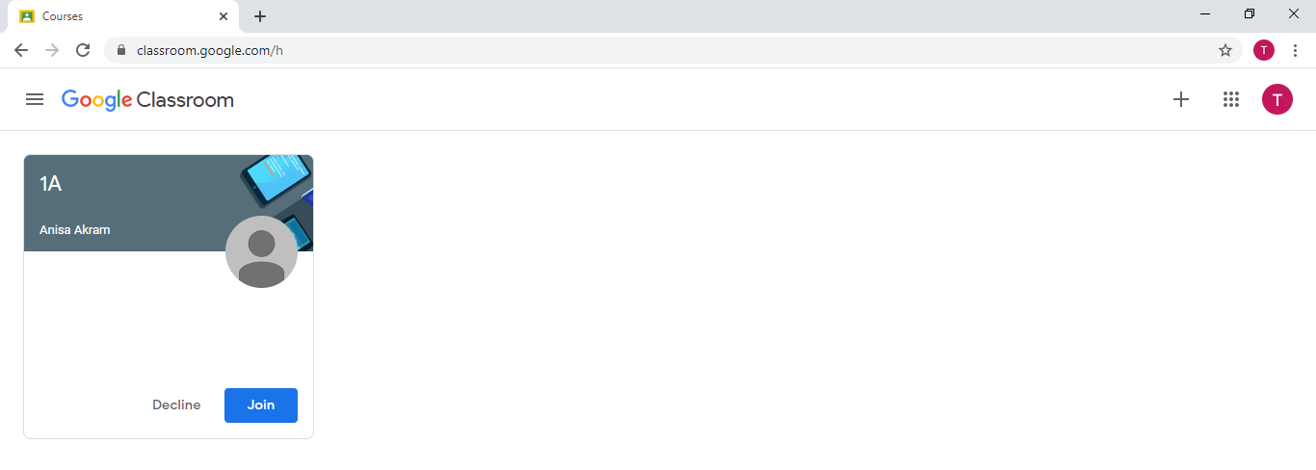
- Once you have clicked on Join or clicked the class, it will take you to the following screen:
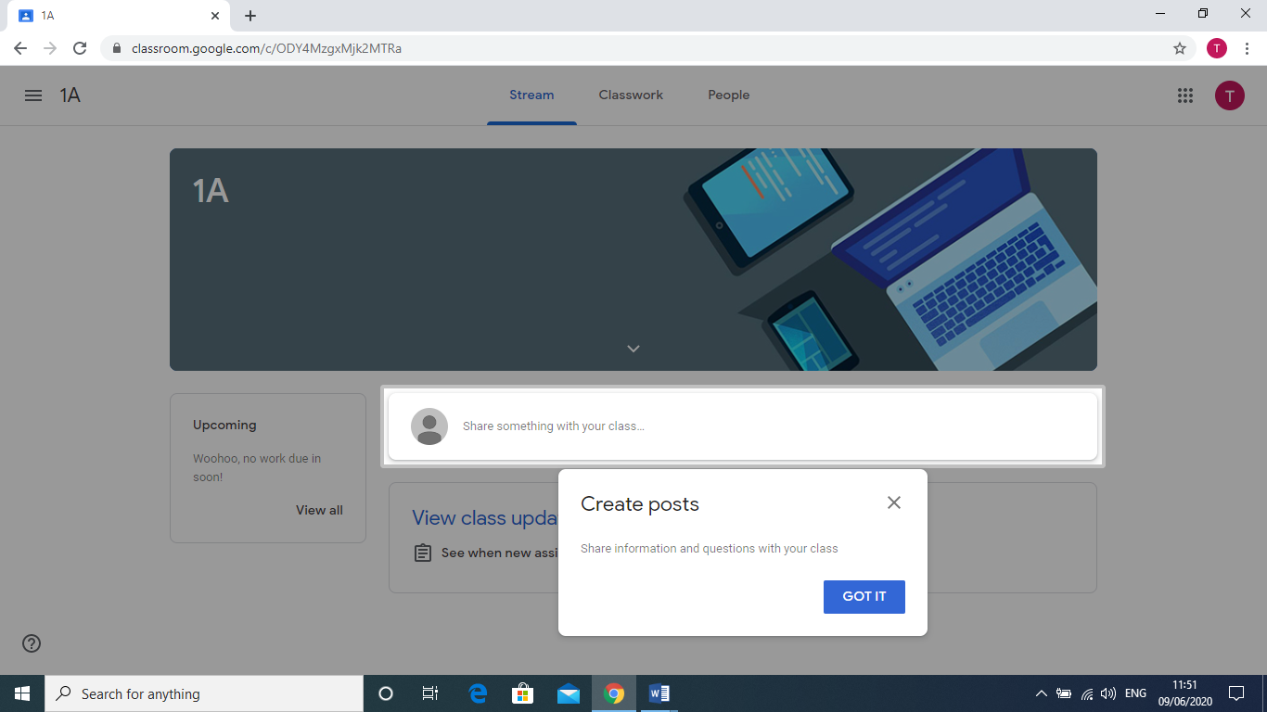

You have now successfully logged in and joined your class. You have been given a youtube link to a video which gives you a tutorial on how to use google classroom for pupils. This youtube link is on your cover letter which has been given to you in the pack. It is important that you watch this video and make yourself familiar with google classroom environment. Further instructions will be provided by your class teacher.

