Google Classroom Features

When you log into your Google Classroom you will see the Stream, Classwork and People tab in the centre of the screen like the picture below:

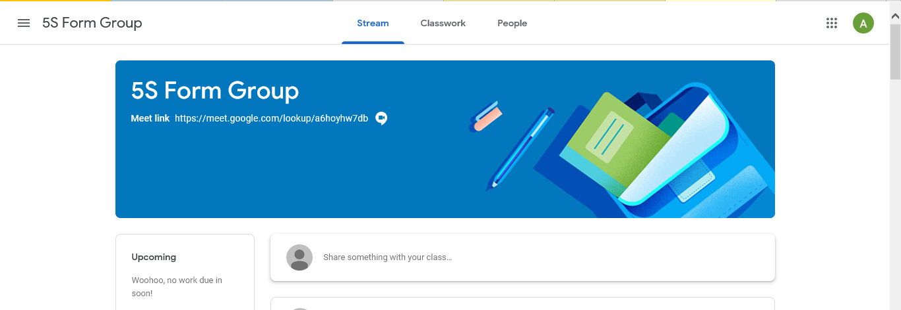

Stream Tab

The Stream tab contains all posts in chronological order from newest to oldest. Teachers could use the stream tab to make announcement to the whole class, set assignments or ask a question. Pupils can also use the stream tab to ask any questions to the teacher. Any comments posted in the stream tab will be seen by all teachers and pupils. To post in the stream tab you will need to type in to the field that says Share something with your class….. and then click on post. You can also add an attachment to the post. Please see picture below:

Classwork Tab

In the classwork tab is where all the assignments, classwork, questions and subject material are posted. All the pupils work will be posted here. Please see picture below:

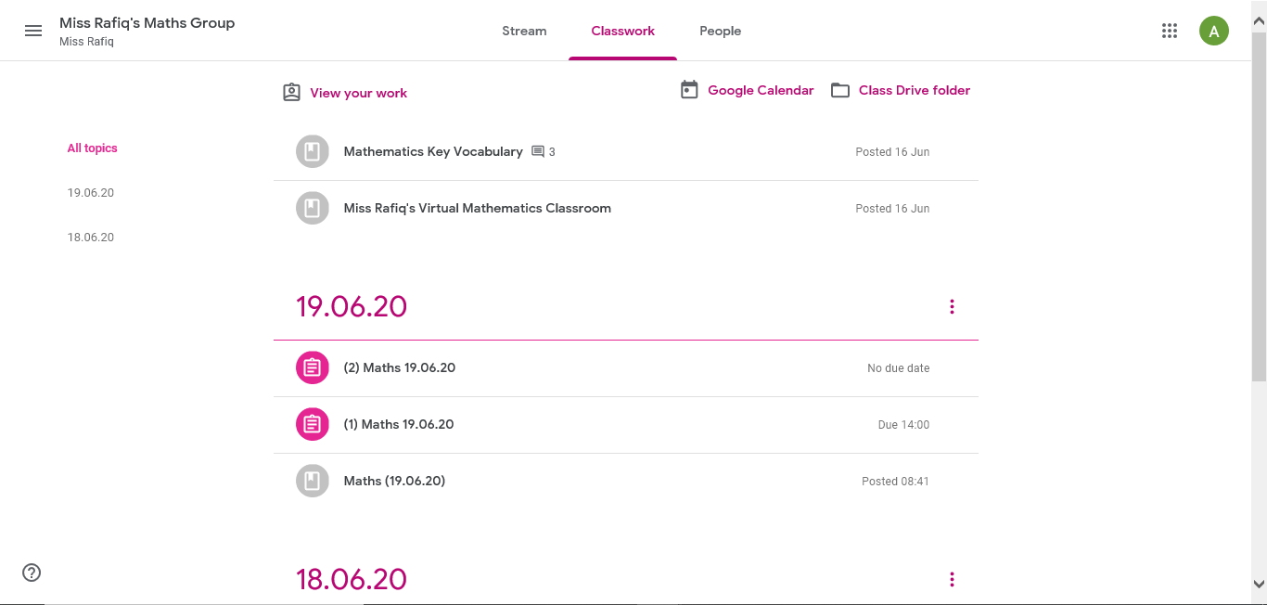

From the above picture you can see a number of assignment posted by the teacher. You will have to click on each post and follow the instructions given by the teacher. You will have to complete the task and submit your work before the deadline given by the teacher.

People Tab

The people tab has a list of all the pupils in your class.

How to Access Live Classes

To access live classes, you will need to click on the Meet link. Please see picture below:

If you are using a laptop, desktop computer or an Apple Mac device it will open up another browser and take you straight to the live session. See picture below:
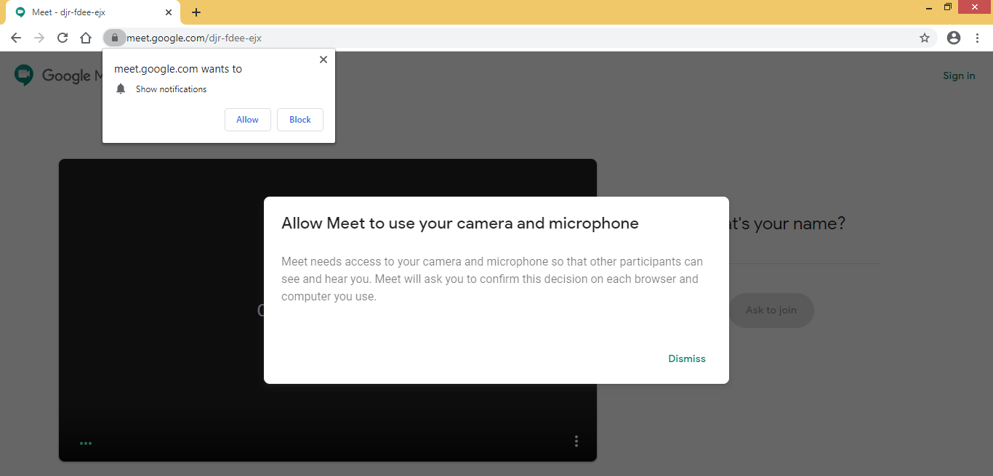
On the above screen you can click on Dismiss to the message. You will have to click on Allow to Show notification. When you click on Allow for Show notification you will get the following notification below:
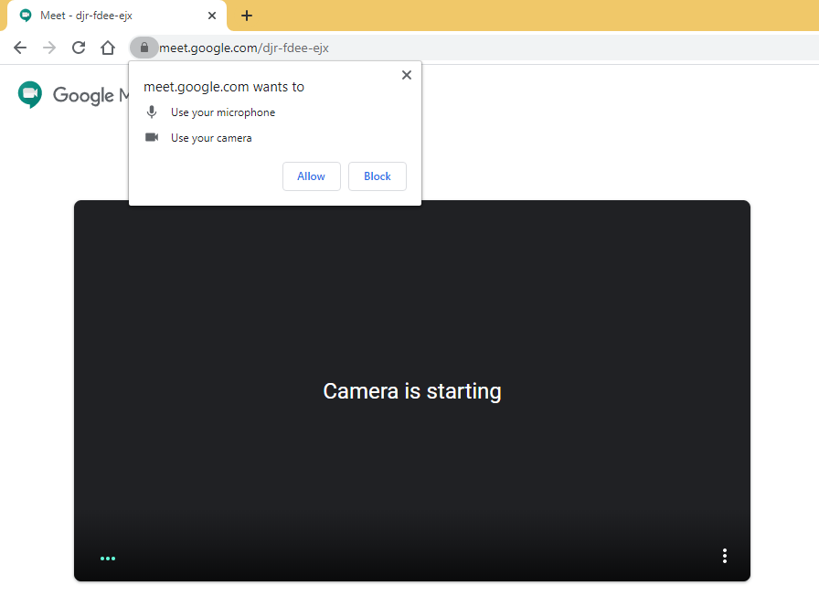
The above notification is to Allow the use of the microphone and camera for the live session. It is important that you click on Allow so the teacher can see you and hear you. Then you click on Join, to join the live meeting with your teacher.
If you are using a tablet or a smart phone, when you click on the Meet link it may take you to the app store to download the Meet app. You should download the Meet app and log into it using the login details for Google Classrooms. This app is free to download. Once you download and log into the Meet app, you will have to go back to the class and click on the Meet link again and that should open up the live session in the Meet app. There will be notifications on screen to use the microphone and camera for the live meeting. It is important that you click on Allow so the teacher can see you and hear you. Then you click on Join, to join the live meeting with your teacher.

